**Department of Electrical and Computer Engineering**

**North South University**



**Senior Design Project**

**E-Textile Based Abuse Alarm Android Application**

**Asadullah Galib ID # 1220292042**

**Syed Mahbubul Huda ID # 1310306042**

**S.M.Saffat Oali ID # 132 0880 042**

**Hasna Hoque Mitu ID# 1410228042**

**Faculty Advisor:**

**Dr. Mahdy Rahman Chowdhury**

**Assistant Professor**

**ECE Department**

**Fall 2018**

**Declaration**

This is to declare that no part of this report or the project has been previously submitted elsewhere for the fulfillment of any other degree or program. Proper acknowledgement has been provided for any material that has been taken from previously published sources in the bibliography section of this report

.........................................................

Md Asadullah Galib Khan

ECE Department

North South University, Bangladesh

........................................................

Syed Mahbubul Huda

ECE Department

North South University, Bangladesh

.........................................................

S.M.Saffat Oali

ECE Department

North South University, Bangladesh

.........................................................

Hasna Hoque Mitu

ECE Department

North South University, Bangladesh

**Approval**

The Senior Design Project entitled “**E-Textile Based Abuse Alarm Android Application**” by Md Asadullah Galib Khan (ID# 1220292042), Syed Mahbubul Huda (ID# 1310306042) ), S.M.Saffat Oali (ID# 1320880042) and Hasna Hoque Mitu (ID# 1410228042) has been accepted as satisfactory and approved for partial fulfillment of the requirement of BS in CSE program on Fall, 2018.

|  |
| --- |
| **Supervisor’s Signature** |
|  |
| **Dr. Mahdy Rahman Chowdhury Assistant Professor**  Department of Electrical and Computer Engineering  North South University  Dhaka, Bangladesh. |
| **Department Chair’s Signature** |
| **Dr. Shazzad Hosain**  **Associate Professor**  Department of Electrical and Computer Engineering  North South University  Dhaka, Bangladesh.  **Acknowledgement**  First of all, we would like to express our profound gratitude to our honorable course instructor, Dr. **Mahdy Rahman Chowdhury,** for his constant and meticulous supervision, valuable suggestions, his patience and encouragement to complete the thesis work.  We would also like to thank the ECE department of North South University for providing us with the opportunity to have an industrial level design experience as part of our curriculum for the undergraduate program.  Finally, we would like to thank our families and everybody who supported us and provided with guidance for the completion of this project. |

**Table of Content**

|  |  |  |
| --- | --- | --- |
|  |  | Page |
|  | **Chapter1: Project Overview**…………………………………………………................................ | 07 |
| 1.1 | Introduction…………………………………………………………………………………………... | 08 |
| 1.2 | Android Operating System ………………………………………………………………………….. | 09 |
| 1.3  1.3.1  1.3.2  1.3.3  1.3.4  1.3.5  1.3.6  1.4  1.5  1.6 | Project Description …………………………………………………………………………………..  Location Feature……………………………………………………………………………………...  Message Feature……………………………………………………………………………………...  Call Feature……………………………………………………………...........................................  Sensor Controlling…………………….……………………………………….……………………..  Nearby Police Station…………………………………………………….…………………………..  Nearby Hospital………………………………………………………………………………………  Pros & Cons………………………………………………………………………………………….  Motivation……………………………………………………………………………………………  Summary……………………………………………………………………………………………. | 10  11  11  12  12  12  13  13  14  14 |
|  |
|  | **Chapter 2: Android Application Overview**……………………………………………………….. | 15 |
| 2.1 | Introduction………………………………………………………………………………………….. | 16 |
| 2.2 | Bluetooth Pairing………………………………………………………….......................................... | 16 |
| 2.3  2.4  2.5 | Emergency Contacts……………………... ………………………………………………………….  Location……………………………………………………………………………………………...  Message…………………..………………………………………….………………………………. | 17  18  20 |
| 2.6  2.7  2.8  2.9  3.1  4.1 | Call………………………………... …………………………………………………………………  Sensor Controlling…………………………………………………………………………………...  Nearby Hospital & Police Station……………………………………………………………………  Summary……………………………………………………………………………………………  **Chapter 3: Conclusion…………………………………………………………………………….**  Conclusion……………………………………………………………………………………………  **Chapter 4: Future Work**  Future Work………………………………………………………………………………………….  **Bibliography…………………………………………………………………………………………**  **Appendices**  **Appendix A: Code Related to Android Studio……………………………………………………** | 21  22  23  24  25  26  27  28  29  31 |

**ABSTRACT**

In this report we present an Android OS based application ‘Rokkha’ which is used to detect any physical abuse occurrence and take necessary measures. This application is designed to find out the location of the victim and notify the occurrence to the emergency contacts. It’s been a long time Women safety has always been an issue in Bangladesh. There hasn’t been any perfect solution to this problem. Having this idea in our mind we have tried to develop this app as a part of our responsibility to the society. There were many other attempts to solve this problem but many have failed to wrap up with a fine solution. On the other hand till now the cost efficiency of those devices was not within the range of the mass people of Bangladesh. And also device portability has been an issue. It was hard to handle the size of the device and also keeping the cost under the affordability of the general mass. The advantage of this particular app is that it acts based on a trigger that is generated by a Bluetooth device which is controlled by an Arduino. The Arduino is connected to a pressure sensing fabric of which women can wear as undergarments. So the pressure sensor fabric triggers a signal to the Arduino which is then sent through the Bluetooth device to the Android application. This kind of application of the Android app and the device has created a new vision to this problem. Now the process of taking measures according to the victim’s current situation has been far easier than before. It has become more faster in case of detecting physical abuse and notify to the emergency contacts which were saved by the user of the application. The user can also use a panic button that is integrated in the device if she feels any threat approaching her. The Android application will do the same in case of this panic button. As there are no external devices needed and it uses our daily utensils like Android phone and undergarments, the portability of this whole combination has never been easier. And the cost has reduced within the reach of the general mass of Bangladesh.

**CHAPTER 1**

**PROJECT OVERVIEW**

* 1. **Introduction**

Mobile phone has turned into a daily utensil in our day today life. Each and every person of the working class is using mobile phones. Among them there is a large number of people who are using phones which are based on Android Operating System. It’s now one of the most used mobile platform or operating system in the whole world. Nowadays mobiles come with powerful sensing, computing and networking capabilities. Though sizes have varied due to modern contemporary design methods but it has almost always been a device to carry along everywhere. This is the opportunity for mankind to turn it into a resource in our life. A lot of mobile application has been created which has altered our way of life. A lot of those haven’t played any important role in our life. But there are very few mobile applications that has empowered our lifestyle and has turned into a necessity. Our main goal was to create something which is very easy to access and very easy to associate with. Bangladesh is a developing country and a large number of the population is still getting introduced to the applications of technology. Thus it was hard for us to find a way to make something which is understandable to most of the people of our country. Woman abuse has been an issue in our society for a very long time. The Indian Sub-Continent has suffered a lot due to this problem. Finding a way out of this we have tried many ways. But sensing the fragrance of modern technology we came to a point where we were certain about solving this matter using our closest friend, mobile phone. This was our first choice to reach for help when someone is in danger. But in many situations it’s not possible to take the time to call or text message someone about the victim’s current situation and whereabouts. So finding out whether the user is being abused or not and to send these information to someone in a quick passage of time needed to be done through an automatic system. Thus how the idea of creating this Android application named ‘Rokkha’ was created and applied.

* 1. **Android Operating System**

The Android Operating System is a Linux-based OS developed by the Open Handset Alliance (OHA). Android OS shipments overtook those of Symbian in the 4th Quarter of 2010, dislodging the later from the number one spot among Smartphone OSs.

Android’s underlying kernel is based on Linux, but it has been customized to suit Google’s directions. There is no support for the GNU libraries and it does not have a native X Windows system. Inside the Linux kernel are found drivers for the display, camera, flash memory, keypad, WiFi and audio. The Linux kernel serves as an abstraction between the hardware and the rest of the software on the phone. It also takes care of core system services like security, memory management, process management and the network stack.   
The Android OS is designed for phones. Its many features include:

* Integrated browser, based on the open source Web Kit engine
* Optimized 2D and 3D graphics, multimedia and GSM connectivity
* Bluetooth
* EDGE
* 3G
* WiFi
* SQLite
* Camera
* GPS
* Compass
* Accelerometer

Software developers who want to create applications for the Android OS can download the Android Software Development Kit (SDK) for a specific version. The SDK includes a debugger, libraries, an emulator, some documentation, sample code and tutorials. For faster development, interested parties can use graphical integrated development environments (IDEs) to write applications in Java.

* 1. **Project Description**

Our project was to create an application for Android Operating System which will take in a Bluetooth signal and it will send the current location along with a message to the emergency contacts. The Bluetooth signal will be triggered by the pressure sensor fabric.

After a certain level of pressure the Arduino will trigger a Bluetooth signal. This Bluetooth must be paired to the corresponding android application consisting mobile. So when the signal will be triggered the app will detect the current location of the victim in the google map and send the map coordinates to the emergency contacts. We have kept a page in our app where the user can set emergency contacts and save a text message to send when the Bluetooth signal triggers. While installing the application it will ask for a few permissions to access like Bluetooth access, Location access, Phone Call access and Message access. The user can choose between Call and Message option. Or they can both be executed simultaneously depending on the user’s choice. User can also control the sensors through the application. As the user might not use the hardware device all the time or might not feel necessary to use at any time, it can be easily stopped through the application.

* + 1. **Location Feature**

Our Android application ‘Rokkha’ has one of the most important features and that is location determining. In order to save the victim from any threat it’s important to find where the occurrence is happening. In the era of modern networking capability it is possible to find out someone’s location through the use of GPS. Here in this app we have allowed this feature that whenever there is a potential threat detected by the hardware and the Bluetooth signal is triggered the app will allow the GPS to extract the position or coordinates using Google Map of the user or victim.

* + 1. **Message Feature**

Text message is one of the most used medium in terms of communication. People all over the world use this default messaging app in the phone. We have used this default feature of a phone to send a text message to the emergency contacts. User has to save these emergency contacts while setting up the application. User can change the contacts anytime when needed. There is a box where the user can write a template message which will be sent automatically when the Bluetooth is triggered. The Google Map coordinates will be sent too through message. If the user saves no template message only the map coordinates will be sent. Keeping it in mind that the message will be sent automatically right after the Bluetooth triggers, it’s better to write the message so everything fall into right places.

* + 1. **Call Feature**

Calling the emergency contacts is another feature in our Android application. Checking the call option in the settings page enables this feature. In our application user can save

up to three emergency contacts. The first number that is saved will have the most priority. So when the Bluetooth signal will trigger among the three contacts the first contact will be the one to call. Text message along with the location will be sent to the other numbers too.

* + 1. **Sensor Controlling**

Sensor controlling is very important in terms of flexibility of using this application. If there arises any situation where the hardware device is needed to be stopped, it can be done through the application. User can also feel not necessary to use the sensors right then. There are two buttons in our application named ‘ACTIVE ONE’ and ‘ACTIVE TWO’. These two buttons corresponds to two sensors each. There are four sensor in total used in the hardware. So the first button will stop two sensors and other one will stop the other two.

* + 1. **Nearby Police Station**

Nearby police station is an option given in our application. If the user enters this option it will show the nearby Police Stations around the victim’s position. Right now this will help the victim to find where the nearest police station is available. So if the victim gets the chance to get away from the current location and go to a safe place, it will be easier for the victim to locate the nearest police station. Google Map is used here to show the nearest stations. Currently we are working on this feature to enhance its privileges. We’ll right about our plans about this feature in the Future Plan section.

* + 1. **Nearby Hospital**

Nearby hospital helps the victim to find the nearest hospitals available from the victim’s location. Here also we have used Google Map as its one the most available and detailed map application to use.

* 1. **Pros & Cons**

There are many good sides to this mobile application. Currently in our country we don’t get to know about the incidents happening around us. After being abused physically females tend to harm themselves due to social prestige and family abundance. Now using this application we’ll get a chance to save the victim. Even if something worst happens we’ll be able to locate the victim and take her for further medical treatment. The downside of this application is its available in only Android devices. There are other operating systems in the market like IOS where this application is not available. In the rural areas of Bangladesh people who don’t use Android devices won’t be able to use this. So a large number of people will be out of application’s range. But we hope that someday in our country technology will reach its fullest to the urban as well as the rural areas too. This application needs internet access to locate the location of the victim and also the nearby hospitals and police stations. If we can tie up with any of the leading telecom companies then we’ll be able to provide free internet to use this particular application. Then it will be more feasible for our general mass to use this application.

* 1. **Motivation**

Women safety has always been an issue in Bangladesh. There hasn’t been any perfect solution to this problem. Having this idea in our mind we have tried to develop this application as a part of our responsibility to the society.

* 1. **Summary**

In this chapter we have briefly described the capabilities and incapabilities of our application. We have described our motivation and the future plan. We have written about all the features of application. We have also emphasized on how this Android application is going to have an impact in a society like Bangladesh.

**Chapter 2**

**Android Application Overview**

**2.1 Introduction**

‘Rokkha’ is what we have named our Android application. Rokkha in Bengali means Safety. Our main objective to build this application was to give security to the women of Bangladesh. We have tried our best to make the user interface as friendly as possible. In this chapter we’ll explain the whole interface with screenshots and other information.

**2.2 Bluetooth Pairing**

First the user needs to turn on the Bluetooth of the Android device. After turning on user will find the Bluetooth used in the Hardware name HC-05. The pairing code is 0000.

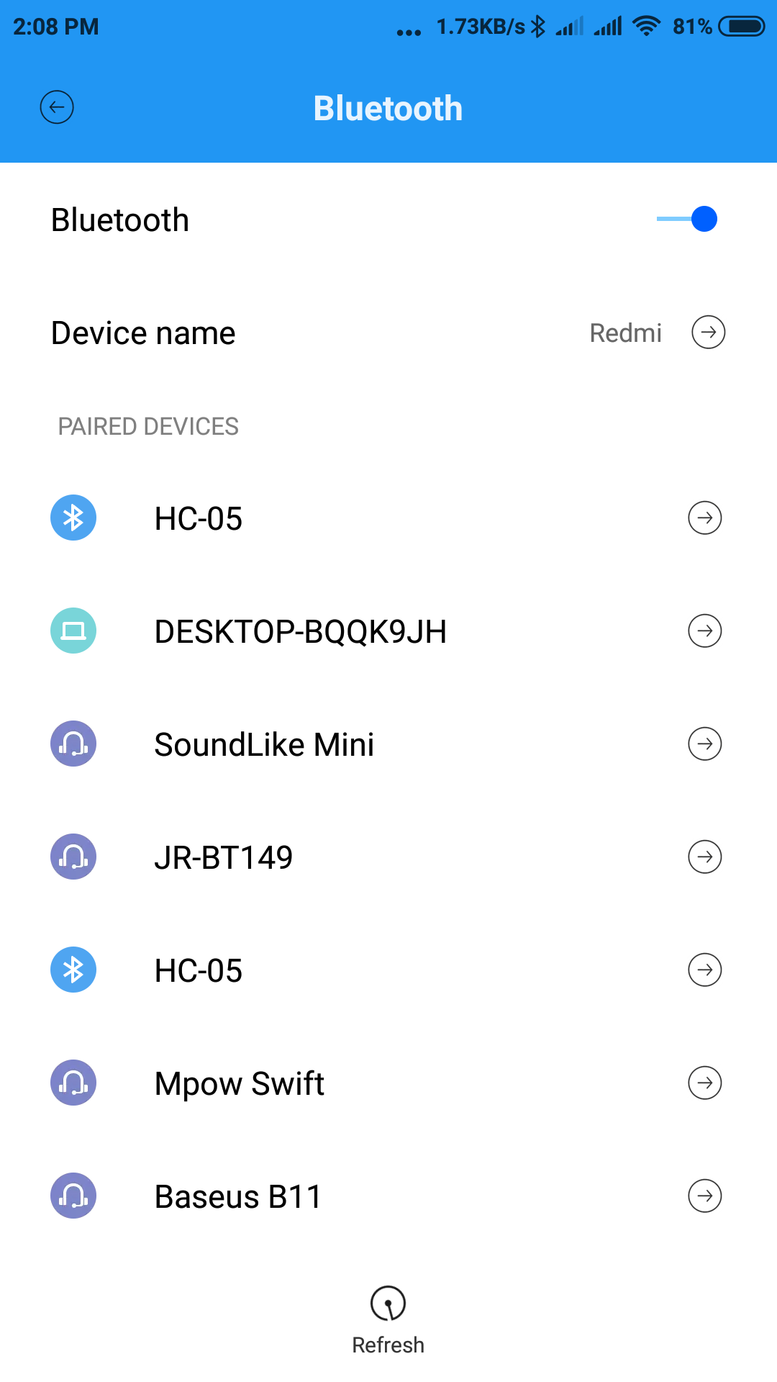

After pairing this Bluetooth the user need to open the application where the connections of all paired devices with the phone will show. From there selecting the port of HC-05 will make the final connection between the Android application and the hardware. As the screenshot is given below.

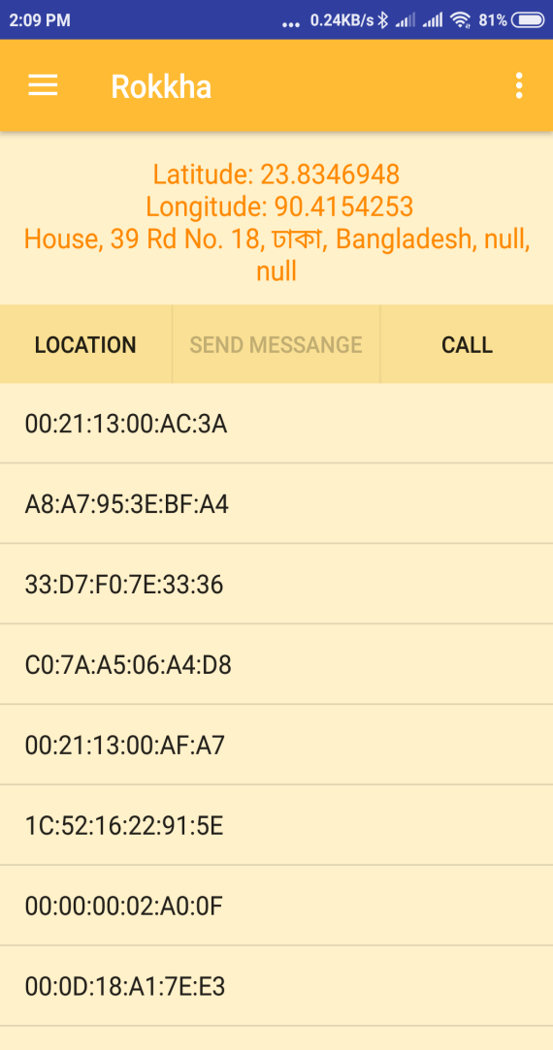

**2.3 Emergency Contacts**

In this page the user will be able to save emergency contacts. There are three spaces to save three contacts. The first one in the queue will be prioritized in terms of the calling action. The rest of the contacts will receive a message consisting the location and the sample text saved by the user earlier.

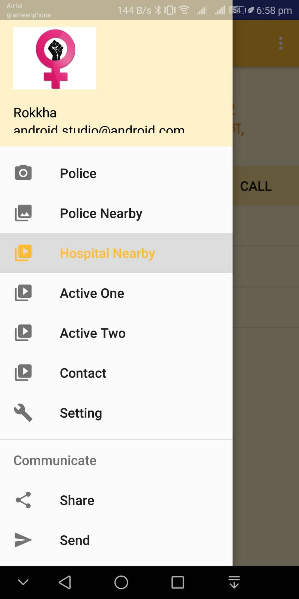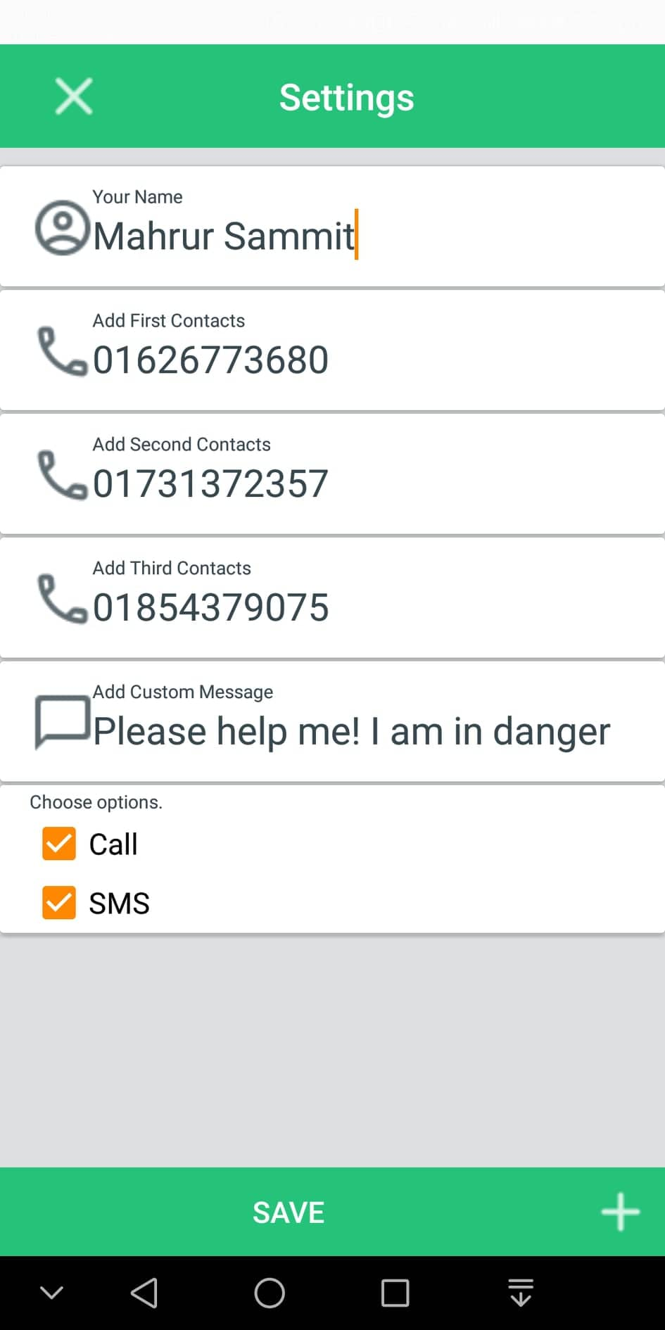

**2.4 Location**

Pairing with the Bluetooth and saving the emergency contacts are the first two activity needed to be done. Now finding the location of the victim is the most important feature in our app. We have used Google Map to find out the location. Today’s world most of the mobile devices have this app called Maps powered by Google. Though our application runs on only Android devices but this Google Map application is available in most of the operating systems running in the market. So we chose this application so that in future if we get to make the app for other platforms too, we’ll be able to use the same map application very easily. So when the Bluetooth is connected and the emergency contacts are saved, whenever any kind of abusive signal is triggered the app will receive it and find the location. The user must activate internet to avail this option.

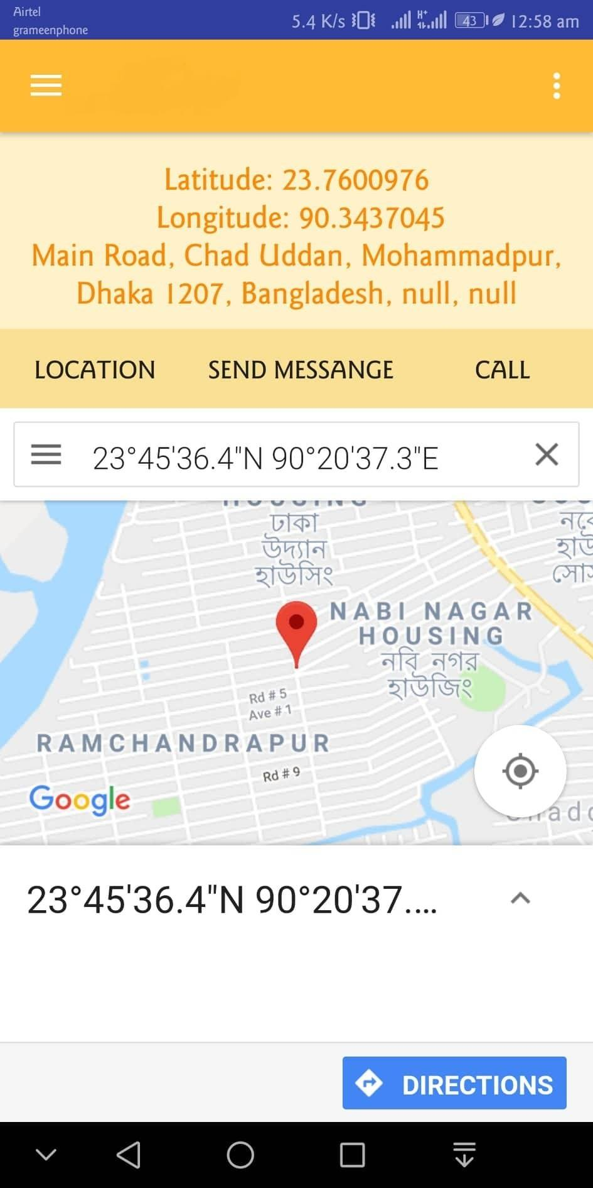

This is how the location will be detected and the coordinates will be copied to send it to the emergency contacts.

**2.5 Message**

This app provides a space for a sample text message which will be sent to the emergency contacts when the victim will be under attack. Just after the Bluetooth trigger the message will be sent to all the emergency contacts along with the current location of the victim. To activate the message option the user needs to check the sms option in the contact page.



**2.6 Call**

To activate the call option, user must go to the Contact page and check the call action. Among three of the contacts the first one will be the one to call. The call action will be generated automatically.





**2.7 Sensor Controlling**

With the Active One and Active Two user will be able to turn on and off the four sensors in the fabric. Active One corresponds to two sensors and Active Two corresponds to the other two sensors.



**2.8 Nearby Hospital & Police Station**

In this tab user will be able to find the nearby Hospital and Police Station in just one click. This will help the victim to reach to the nearest hospital and police station in short time if possible. People who’ll come to help the victim will be able to find these easily too. It makes decision making easier for the victim as well as the saver.



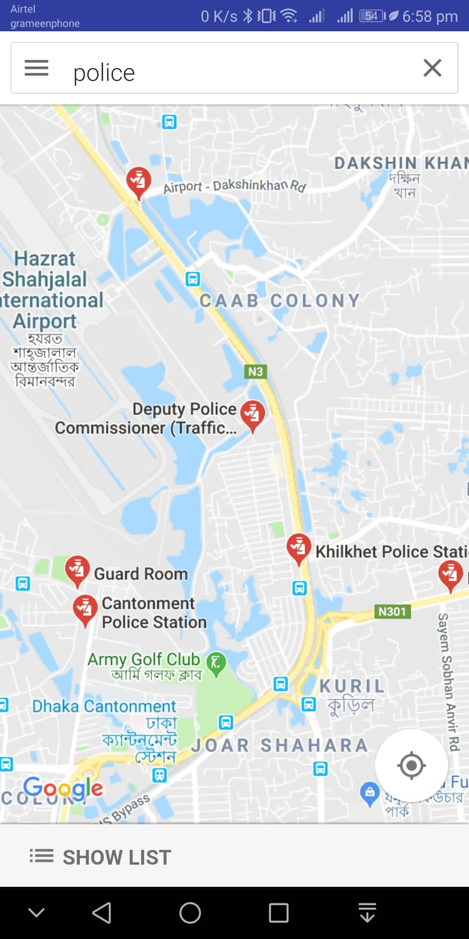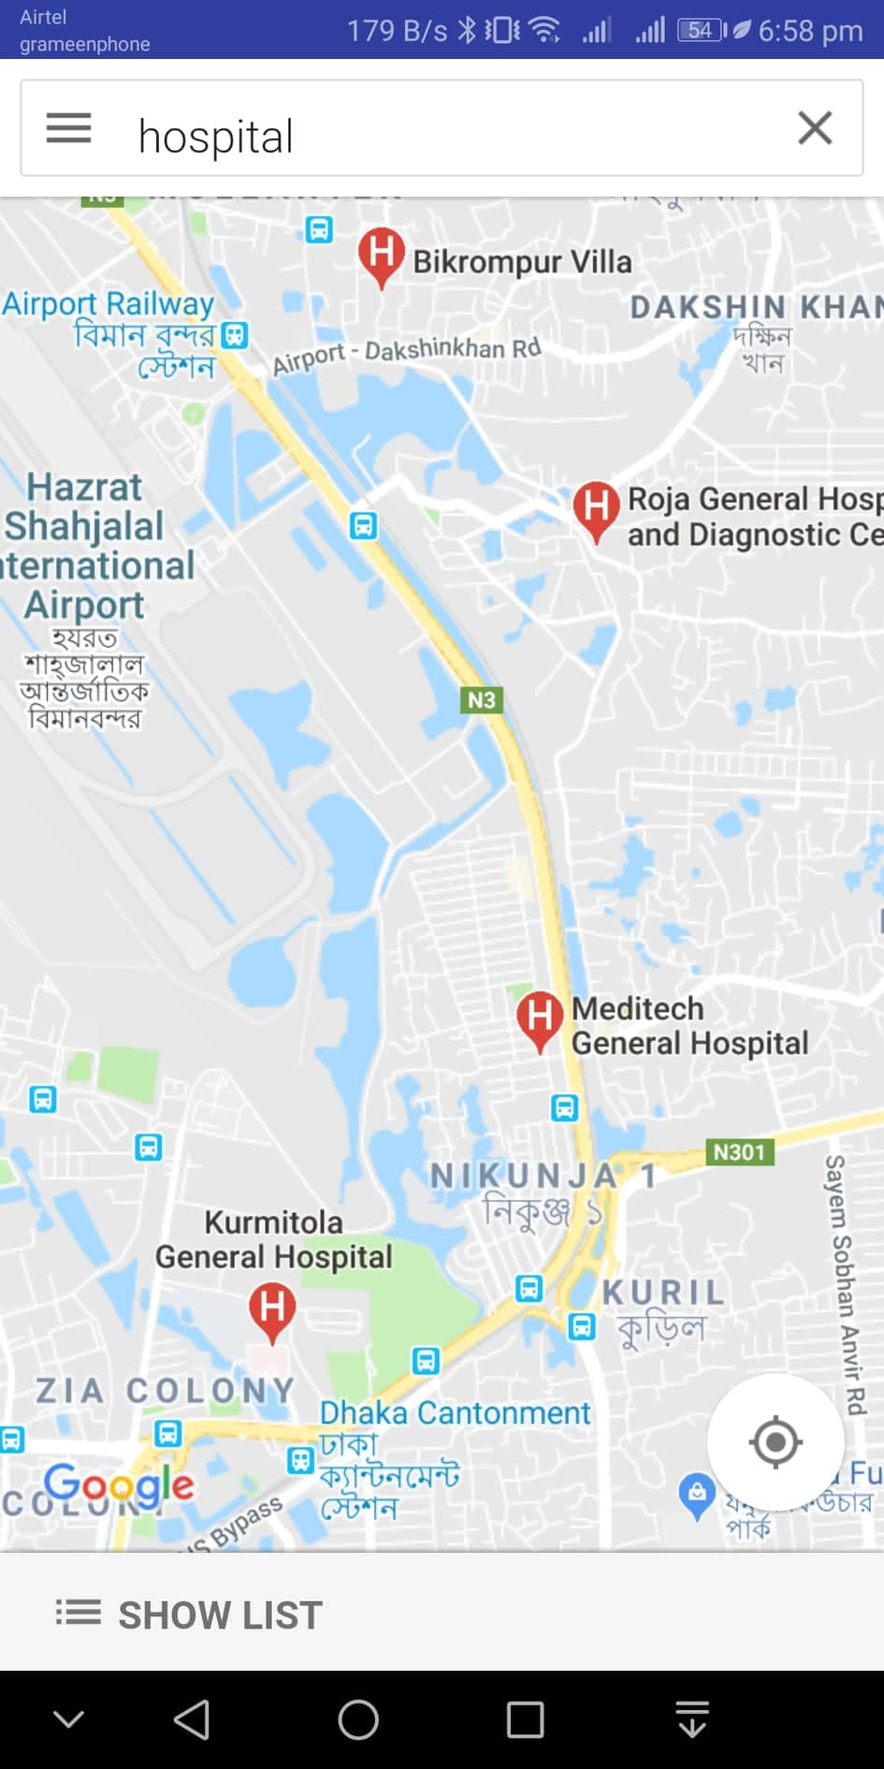

**Nearby Police Stations Nearby Hospitals**

**2.9 Summary**

In this section we have explained the features along with screenshots. We have described how to connect with the Bluetooth and then operating the Android application. All the features are explained in this section which will make this app more user friendly to the user.

**Chapter 3**

**Conclusion**

**3.1 Conclusion**

This Android application has the possibility of creating a new horizon of the betterment of a country. Bangladesh has been suffering for a long time in terms giving security to the women. Still now in 2018 there are hundreds and thousands of cases of rape and abuse on women. Law enforcement has never been implemented properly in our country. This situation has been the same since the beginning of time in Bangladesh. Justice hasn’t been served to the victim and to the criminal also. People haven’t found any way to stop or get out of it. This Anroid application can change the view of the general people. Now there is a way to prevent these kinds of criminal acts. Women now can be more confident and more conscious exploring her own life.

**Chapter 4**

**Future Work**

**4.1 Future Work**

There are few features that we have planned and we are trying to execute those. In our application when the Bluetooth signal is triggered the preferred action, call or message is being executed immediately. We’ll add a buffer time in between so the number of false alarm will be lesser. There will be a few occurrence when there is no actual abusive act happening but due to other activities the signal might trigger. So we’ll add a buffer time of 5 seconds where the application will ask the victim whether to execute the action. If the user doesn’t respond the actions will be taken automatically after five seconds. We also have a plan to tie up with a telecom company of Bangladesh so that we can provide free of charge internet for the use of this particular application.

**Bibliography**

[1] W. Zhang, Software Engineering and knowledge engineering: Theory and Practice, pp. 247-257, 2012

[2] K. Borre, D. Akos, N. Bertelsen, P. Rinder, S. Jensen, "A Software-Defined GPS and Galileo Receiver: Single-Frequency Approach" in , Boston, MA:Birkhäuser, 2006.

[3] Smart security solution for women based on Internet Of Things”(IOT), G.C.Harikiran, Karthik Menasinkai, Suhas Shirol, International Conference on ICEEOT,IEEEXplore, 24-Nov-2016 “Women’s Safety Using IOT“ Prof.R.A.Jain, Adityapatil,Prasenjeet Nikam, Shubham More,SaurabhTotewar,International Research Journal Of Engineering and Technology(IRJET) volume:04 Issue:05- may-2017.

[4] I. Suberviola, I. Mayordome, J. Mendizabal, "Experimental results of air target detection with GPS forward scattering radar", 2012 IEEE Geoscience and Remote Sensing Letters, vol. 9, no. 1, pp. 47-51, 2012.

[5] V. Behar, Chr. Kabakchiev, H. Rohling, "Air Target Detection Using Navigation Receivers Based on GPS L5 Signals", Proc. of ION GNSS’2011, pp. 333-337, 2011.

[6] Chr. Kabakchiev, I. Garvanov, V. Behar, H. Rohling, A. Lazarov, "The Experimental Study of Target FSR Shadows Detection using GPS signals", Proc. of the Third International Symposium on Radio Systems and Space Plasma, pp. 64-73, 2013.

[7] Chr. Kabakchiev, I. Garvanov, V. Behar, P. Daskalov, H. Rohling, "Moving Target FSR Shadow Detection using GPS signals", Proc. of the Third International Conference on Telecommunications and Remote Sensing (ICTRS 2014), pp. 34-40, 26–27 June, 2014.

**Appendix A**

**Codes Related to Android Studio**

**Main Activity Logic Code**

public class MainActivityextends SettingActivity  
implements NavigationView.OnNavigationItemSelectedListener,LocationListener{  
  
  
final int SEND_SMS_PERMISSION_REQUEST_CODE = 111;  
 private Button mSendMessageBtn;  
Button getLocationBtn,setting,call,police;  
TextViewlocationText;  
 double l;  
 double n;  
String a;  
String ll;  
String nn;  
LocationManagerlocationManager;  
Bundle bundle = new Bundle();  
Bundle b = new Bundle();  
  
  
  
@Override  
protected void onCreate(Bundle savedInstanceState) {  
super.onCreate(savedInstanceState);  
setContentView(R.layout.activity_main);  
Toolbar toolbar = (Toolbar) findViewById(R.id.toolbar);  
setSupportActionBar(toolbar);  
  
FloatingActionButton fab = (FloatingActionButton) findViewById(R.id.fab);  
fab.setOnClickListener(new View.OnClickListener() {  
 @Override  
public void onClick(View view) {  
Snackbar.make(view, "Replace with your own action", Snackbar.LENGTH_LONG)  
 .setAction("Action", null).show();  
}  
 });  
  
DrawerLayout drawer = (DrawerLayout) findViewById(R.id.drawer_layout);  
ActionBarDrawerToggle toggle = new ActionBarDrawerToggle(  
this, drawer, toolbar, R.string.navigation_drawer_open, R.string.navigation_drawer_close);  
drawer.addDrawerListener(toggle);  
toggle.syncState();  
  
NavigationViewnavigationView = (NavigationView) findViewById(R.id.nav_view);  
navigationView.setNavigationItemSelectedListener(this);  
  
  
  
  
  
  
  
  
mSendMessageBtn = (Button) findViewById(R.id.btn_send_message);  
/* police=(Button)findViewById(R.id.police);  
police.setOnClickListener(new View.OnClickListener() {  
 @Override  
 public void onClick(View view) {  
 Intent intent=new Intent(MainActivity.this, PoliceActivity.class);  
intent.putExtras(bundle);  
intent.putExtras(b);  
startActivity(intent);  
 }  
 });  
  
*/  
mSendMessageBtn.setEnabled(false);  
 if(checkPermission(Manifest.permission.SEND_SMS)) {  
mSendMessageBtn.setEnabled(true);  
}else {  
ActivityCompat.requestPermissions(this, new String[] {Manifest.permission.SEND_SMS},  
SEND_SMS_PERMISSION_REQUEST_CODE);  
}  
mSendMessageBtn.setOnClickListener(new View.OnClickListener() {  
 @Override  
public void onClick(View view) {  
  
 String message = "My Location is : ("+"http://www.google.com/maps/place/" + l +","+ n+")";  
  
String phoneNo = getPhone();  
//Toast.makeText(getApplicationContext(), "This is my Toast message!\n"+a, Toast.LENGTH_LONG).show();  
  
if(!TextUtils.isEmpty(message) && !TextUtils.isEmpty(phoneNo)) {  
  
if(checkPermission(Manifest.permission.SEND_SMS)) {  
SmsManagersmsManager = SmsManager.getDefault();  
smsManager.sendTextMessage(phoneNo, null, getName()+","+getSms()+"\n"+message, null, null);  
}else {  
Toast.makeText(MainActivity.this, "Permission denied", Toast.LENGTH_SHORT).show();  
}  
 }  
 }  
 });  
  
getLocationBtn = (Button)findViewById(R.id.getLocationBtn);  
  
locationText = (TextView)findViewById(R.id.locationText);  
  
/* setting=(Button)findViewById(R.id.setting);  
  
  
setting.setOnClickListener(new View.OnClickListener() {  
 @Override  
 public void onClick(View view) {  
  
 Intent intent=new Intent(MainActivity.this, SettingActivity.class);  
  
startActivity(intent);  
  
  
 }  
 });  
*/  
  
if (ContextCompat.checkSelfPermission(getApplicationContext(), android.Manifest.permission.ACCESS_FINE_LOCATION) != PackageManager.PERMISSION_GRANTED&&ActivityCompat.checkSelfPermission(getApplicationContext(), android.Manifest.permission.ACCESS_COARSE_LOCATION) != PackageManager.PERMISSION_GRANTED) {  
  
ActivityCompat.requestPermissions(this, new String[]{android.Manifest.permission.ACCESS_FINE_LOCATION, android.Manifest.permission.ACCESS_COARSE_LOCATION}, 101);  
  
}  
  
getLocation();  
getLocationBtn.setOnClickListener(new View.OnClickListener() {  
 @Override  
public void onClick(View v) {  
getLocation();  
Toast.makeText(getApplicationContext(), "This is my Toast message!\n"+a, Toast.LENGTH_LONG).show();  
}  
  
 });  
  
  
  
  
  
call=(Button)findViewById(R.id.call);  
call.setOnClickListener(new View.OnClickListener() {  
 @Override  
public void onClick(View view) {  
 call();  
}  
 });  
  
  
  
  
  
  
  
  
}  
  
  
  
private void call() {  
  
 Intent callIntent = new Intent(Intent.ACTION_CALL); //use ACTION_CALL class  
callIntent.setData(Uri.parse("tel:"+getPhone())); //this is the phone number calling  
 //check permission  
 //If the device is running Android 6.0 (API level 23) and the app's targetSdkVersion is 23 or higher,  
 //the system asks the user to grant approval.  
if (ActivityCompat.checkSelfPermission(this, Manifest.permission.CALL_PHONE) != PackageManager.PERMISSION_GRANTED) {  
//request permission from user if the app hasn't got the required permission  
ActivityCompat.requestPermissions(this,  
 new String[]{Manifest.permission.CALL_PHONE}, //request specific permission from user  
10);  
 return;  
}else { //have got permission  
try{  
startActivity(callIntent); //call activity and make phone call  
}  
catch (android.content.ActivityNotFoundException ex){  
Toast.makeText(getApplicationContext(),"yourActivity is not founded",Toast.LENGTH_SHORT).show();  
}  
 }  
  
 }  
  
private booleancheckPermission(String permission) {  
int checkPermission = ContextCompat.checkSelfPermission(this, permission);  
 return (checkPermission == PackageManager.PERMISSION_GRANTED);  
}  
  
 @Override  
public void onRequestPermissionsResult(int requestCode, @NonNull String[] permissions, @NonNullint[] grantResults) {  
switch (requestCode) {  
case SEND_SMS_PERMISSION_REQUEST_CODE: {  
if(grantResults.length>0 && (grantResults[0] == PackageManager.PERMISSION_GRANTED)) {  
mSendMessageBtn.setEnabled(true);  
}  
return;  
}  
 }  
 }  
  
  
 @Override  
public void onBackPressed() {  
DrawerLayout drawer = (DrawerLayout) findViewById(R.id.drawer_layout);  
 if (drawer.isDrawerOpen(GravityCompat.START)) {  
drawer.closeDrawer(GravityCompat.START);  
} else {  
super.onBackPressed();  
}  
 }  
  
 @Override  
public booleanonCreateOptionsMenu(Menu menu) {  
// Inflate the menu; this adds items to the action bar if it is present.  
getMenuInflater().inflate(R.menu.main, menu);  
 return true;  
}  
  
 @Override  
public booleanonOptionsItemSelected(MenuItem item) {  
// Handle action bar item clicks here. The action bar will  
 // automatically handle clicks on the Home/Up button, so long  
 // as you specify a parent activity in AndroidManifest.xml.  
int id = item.getItemId();  
  
//noinspectionSimplifiableIfStatement  
if (id == R.id.action_settings) {  
 Intent intent=new Intent(MainActivity.this, SettingActivity.class);  
  
startActivity(intent);  
}  
  
return super.onOptionsItemSelected(item);  
}  
  
 @SuppressWarnings("StatementWithEmptyBody")  
 @Override  
public booleanonNavigationItemSelected(MenuItem item) {  
// Handle navigation view item clicks here.  
int id = item.getItemId();  
  
 if (id == R.id.nav_camera) {  
// Handle the camera action  
Intent intent=new Intent(MainActivity.this, PoliceActivity.class);  
startActivity(intent);  
  
} else if (id == R.id.nav_gallery) {  
 Intent intent=new Intent(MainActivity.this, PoliceNearbyActivity.class);  
intent.putExtras(bundle);  
intent.putExtras(b);  
startActivity(intent);  
  
} else if (id == R.id.nav_slideshow) {  
 Intent intent=new Intent(MainActivity.this, HospitalNearbyActivity.class);  
intent.putExtras(bundle);  
intent.putExtras(b);  
startActivity(intent);  
  
} else if (id == R.id.nav_manage) {  
 Intent intent=new Intent(MainActivity.this, SettingActivity.class);  
  
startActivity(intent);  
  
} else if (id == R.id.nav_share) {  
  
 } else if (id == R.id.nav_send) {  
  
 }  
  
DrawerLayout drawer = (DrawerLayout) findViewById(R.id.drawer_layout);  
drawer.closeDrawer(GravityCompat.START);  
 return true;  
}  
void getLocation() {  
try {  
locationManager = (LocationManager) getSystemService(Context.LOCATION_SERVICE);  
locationManager.requestLocationUpdates(LocationManager.NETWORK_PROVIDER, 5000, 5, this);  
}  
catch(SecurityException e) {  
e.printStackTrace();  
}  
 }  
  
 @Override  
public void onLocationChanged(Location location) {  
locationText.setText("Latitude: " + location.getLatitude() + "\n Longitude: " + location.getLongitude());  
l=location.getLatitude();  
n=location.getLongitude();  
ll = Double.toString(l);  
nn = Double.toString(n);  
//Create the bundle  
  
 //Add your data to bundle  
bundle.putString("chatname", ll);  
b.putString("id",nn);  
  
//Add the bundle to the intent  
  
  
try {  
 Geocoder geocoder = new Geocoder(this, Locale.getDefault());  
List<Address> addresses = geocoder.getFromLocation(location.getLatitude(), location.getLongitude(), 1);  
locationText.setText(locationText.getText() + "\n"+addresses.get(0).getAddressLine(0)+", "+  
addresses.get(0).getAddressLine(1)+", "+addresses.get(0).getAddressLine(2));  
a=locationText.getText() + "\n"+addresses.get(0).getAddressLine(0)+", "+  
addresses.get(0).getAddressLine(1)+", "+addresses.get(0).getAddressLine(2);  
  
WebView myWebView = (WebView) findViewById(R.id.webview);  
myWebView.getSettings().setJavaScriptEnabled(true);  
myWebView.setWebViewClient(new WebViewClient());  
myWebView.loadUrl("http://www.google.com/maps/place/"+l+","+n);  
}catch(Exception e)  
 {  
  
 }  
 }  
  
 @Override  
public void onStatusChanged(String s, int i, Bundle bundle) {  
  
 }  
  
 @Override  
public void onProviderEnabled(String s) {  
Toast.makeText(MainActivity.this, "Please Enable GPS and Internet", Toast.LENGTH_SHORT).show();  
}  
  
 @Override  
public void onProviderDisabled(String s) {  
  
 }  
}

**Hospital Nearby Code**

public class HospitalNearbyActivityextends AppCompatActivity {  
  
 @Override  
protected void onCreate(Bundle savedInstanceState) {  
super.onCreate(savedInstanceState);  
setContentView(R.layout.activity_hospital_nearby);  
ActionBaractionBar = getSupportActionBar();  
actionBar.hide();  
  
//Get the bundle  
Bundlebundle = getIntent().getExtras();  
  
//Extract the data…  
String latitude = bundle.getString("chatname");  
String longitude = bundle.getString("id");  
  
WebView myWebView = (WebView) findViewById(R.id.webview);  
myWebView.getSettings().setJavaScriptEnabled(true);  
myWebView.setWebViewClient(new WebViewClient());  
myWebView.loadUrl("http://www.google.com/maps/search/hospital/@"+latitude+","+longitude+",16z");  
  
}  
}

**Police Stations Nearby Code**

package mahbub.rokkha;  
  
import android.support.v7.app.ActionBar;  
import android.support.v7.app.AppCompatActivity;  
import android.os.Bundle;  
import android.webkit.WebView;  
import android.webkit.WebViewClient;  
  
public class PoliceNearbyActivityextends AppCompatActivity {  
  
 @Override  
protected void onCreate(Bundle savedInstanceState) {  
super.onCreate(savedInstanceState);  
setContentView(R.layout.activity_police_nearby);  
ActionBaractionBar = getSupportActionBar();  
actionBar.hide();  
//Get the bundle  
Bundlebundle = getIntent().getExtras();  
  
//Extract the data…  
String latitude = bundle.getString("chatname");  
String longitude = bundle.getString("id");  
  
WebView myWebView = (WebView) findViewById(R.id.webview);  
myWebView.getSettings().setJavaScriptEnabled(true);  
myWebView.setWebViewClient(new WebViewClient());  
myWebView.loadUrl("http://www.google.com/maps/search/police/@"+latitude+","+longitude+",16z");  
}  
}